**TEST CASES**

**Test case – 1**

**Query :** Who is the lead role in the move 3 idiots

**Solution:**

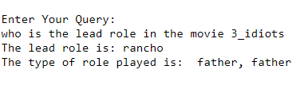

**Test case – 2**

**Query:** What is the attitude of the character aamir khan in the movie 3 idiots?

**Solution:**

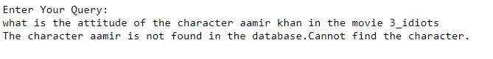

**Test case – 3**

**Path of image:** C:\**\**\****

**Solution:**

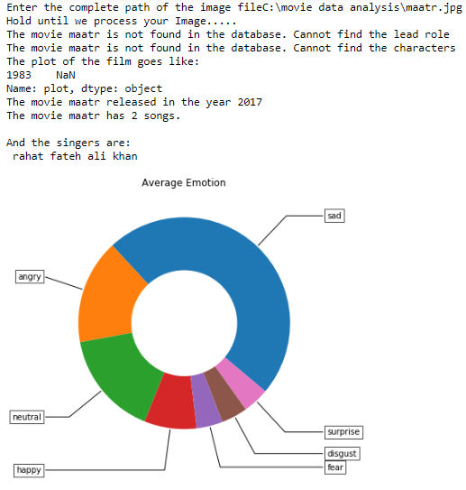

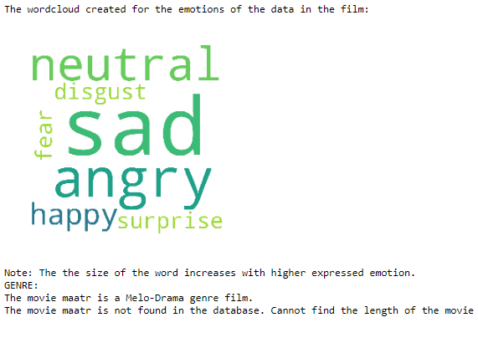

**Test case – 4**

**Query :** what is the variation in movie year-wise and what is the genre of the movie 3 idiots?

**Solution:**

